**REPORT**

**Problem Statement 1:**

Perform required operation on the image if the image is provided by user while compiling the AS2.py file otherwise capture image through camera and perform those operations continuously.

**Proposed Solution:**

This part of the code has been implement using Python command line argument functionality. Here my code will take user’s given image if AS2.py file is compiled along with any image which is being checked by the condition sys.argv==2 whereas if sys.argv<2 then my code will continuously capture image through camera to do the required operations.

In order to compile AS2.py file with given image please use below command in terminal,

**python AS2.py image path**

In order to run it for camera image please use below command,

**python AS2.py**

**Problem Statement 2:**

Save the current image into ‘out.jpg’ when ‘w’ key is pressed.

**Proposed Solution:**

In order to implement this functionality, I have simply implemented cv2.imwrite function from OpenCV which will write the processed image in local directory as ‘out.jpg’

**Problem Statement 3:**

Convert the image to grayscale using openCV function when ‘g’ key is pressed**.**

**Proposed Solution:**

This functionality has been implemented using cv2.cvtColor() function from openCV which will simply convert our RGB image into grayscale image when ‘g’ key is pressed.

**Result:**

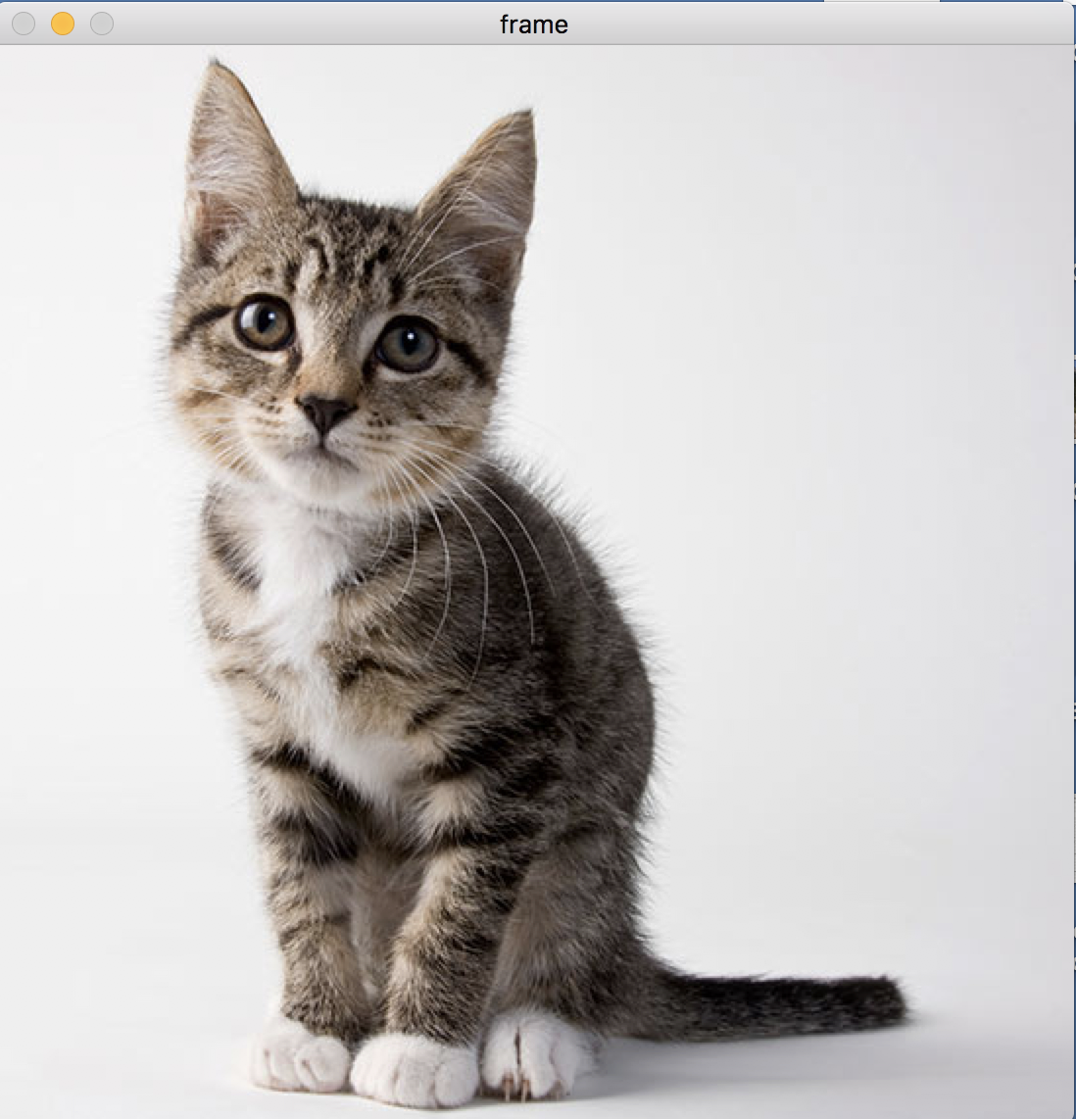

**Original Image in RGB**

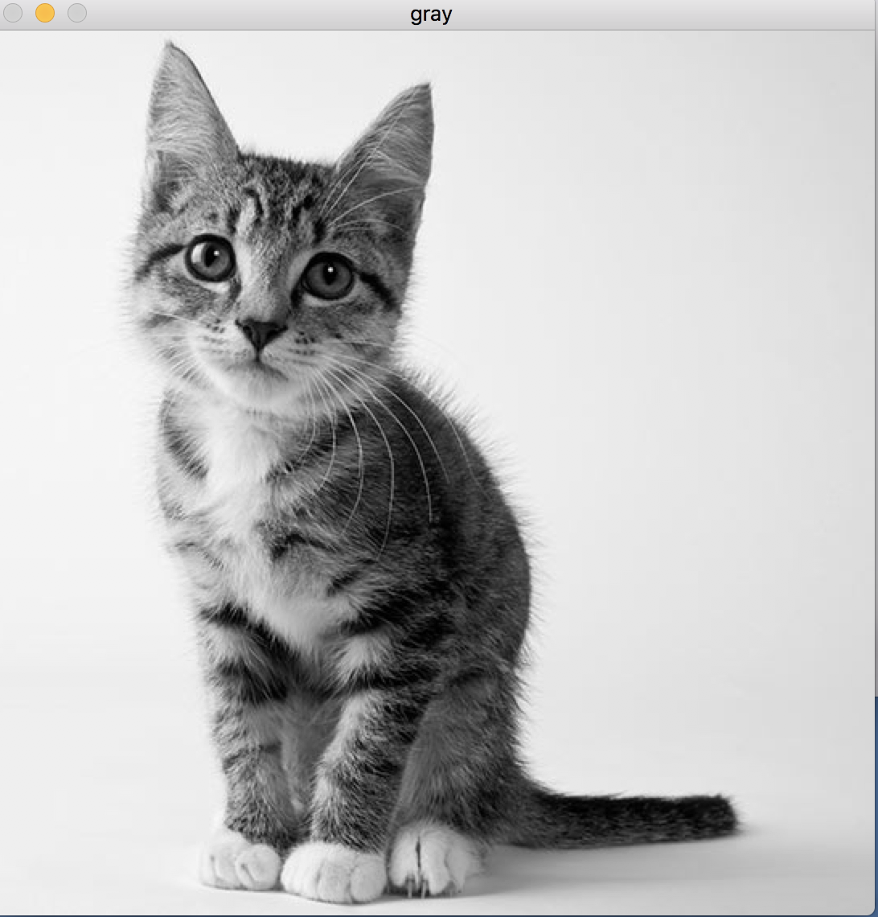

**Converted GrayScale image using openCV**

**Problem Statement 4:**

Convert the image to grayscale using own implemented function when ‘G’ key is pressed

**Proposed Solution:**

As mentioned clearly that we will have to use our own implementation for grayscale conversion for this part. In my own implementation, I am getting the matrix for each channel(R,G,B) and then using below formula to convert to grayscale from RGB.

grayScaleImage = 0.299 * RGB[0] + 0.587 *RGB[1] + 0.114 *RGB[2]

**Result:**



**Original Image**



**Converted Grayscale image using own implementation.**

**Problem Statement 5:**

Cycle through the color channels of the image and show a different channel every time ‘c’ key is pressed.

**Proposed Solution:**

In order to get the channel matrix, my code is first calculating column and row matrix for the given image for each channel(R,G,B). After finding the matrix, it’s simply iterating through different image channel each time ‘c’ key is pressed from keyboard.

**Result:**



**Original Image**

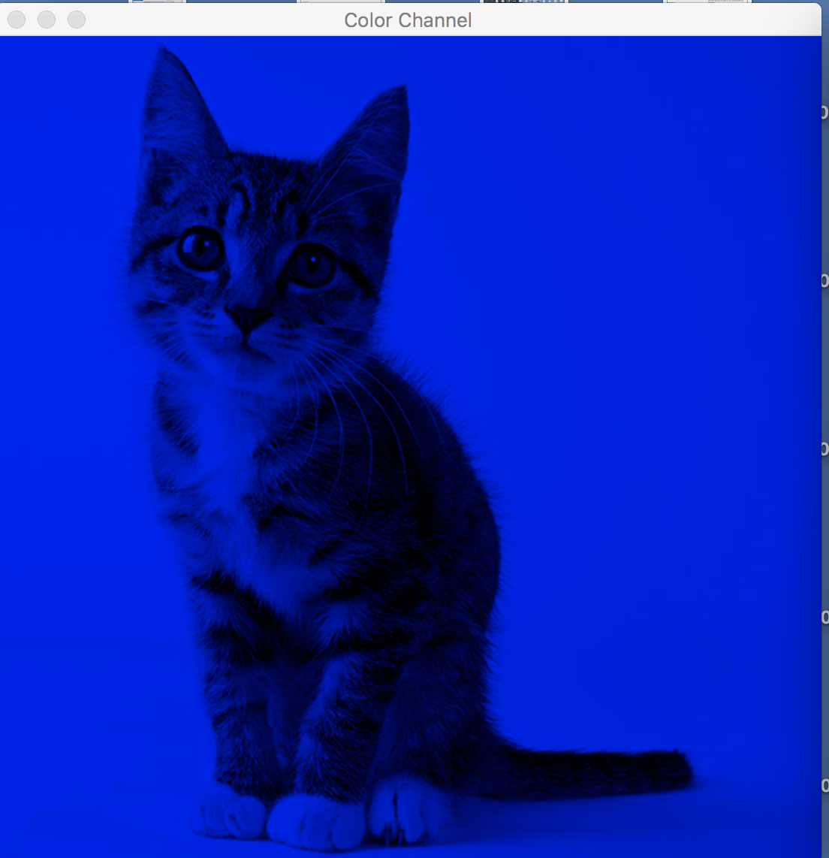

**Blue color Channel**

**Problem Statement 6:**

Convert the given image into grayscale and then use smoothing when ‘s’ key is pressed.

**Proposed Solution:**

Just like the above I am using same cv2. cvtColor() function to convert it into a grayscale image. After getting the grayscale image, I am simply applying smoothing using Gaussian filtering with value of (7,7).  Gaussian filtering is done by convolving each point in the input array with a *Gaussian kernel* and then summing them all to produce the output array. I have used below line of code to applying Gaussian filtering in order to do convolution.

blur = cv2.GaussianBlur(gray, (7,7), 0)

I have also implemented Trackbar to through which amount of smoothing can be controlled. This trackbar has been implemented using cv2.createTrackbar() function which is taking a minVal and maxVal of 0 and 225 for the scale. Every time user changes the amount of smoothing, my code is capturing the position for the trackbar and putting the value as input to the Gaussian kernel thus it will change the convolution based on the given value.

Implementing trackbar in python was huge challenge as it freezes the output window for openCV.

**Result:**



**Original Image**

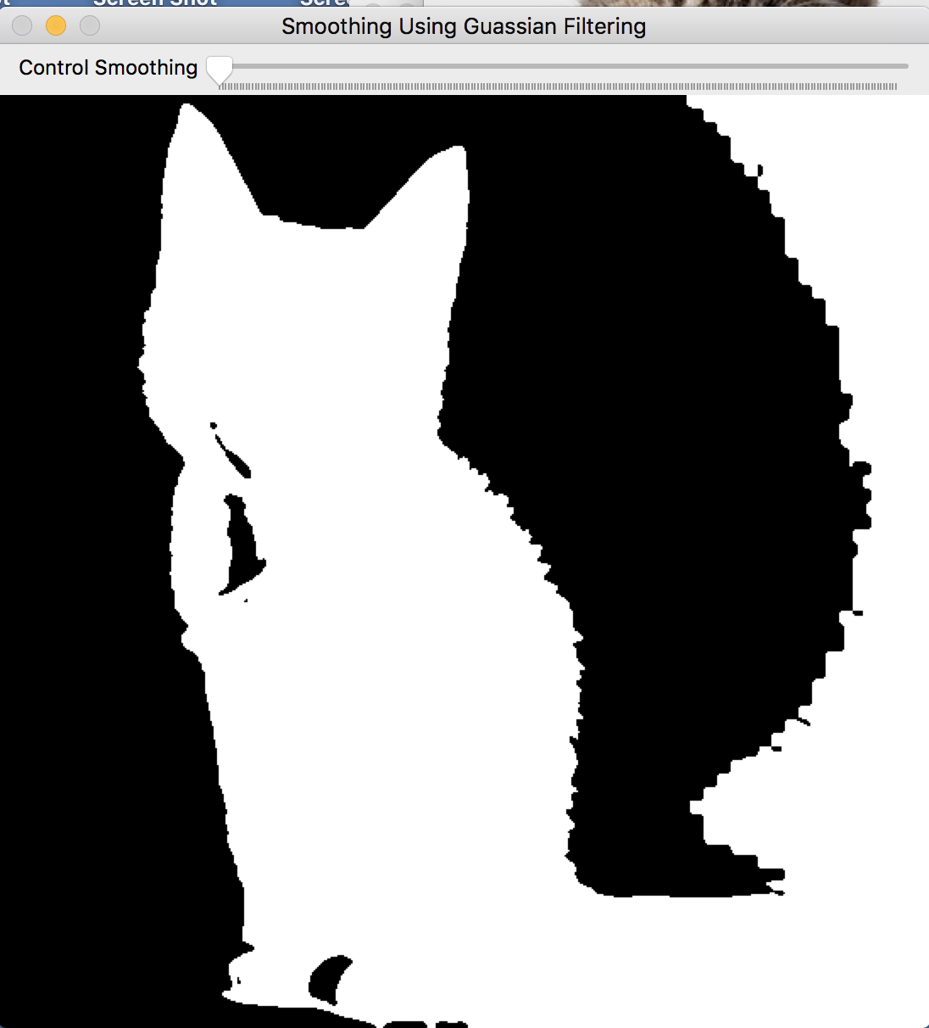

**Smoothing with Gaussian Filter(7,7)**

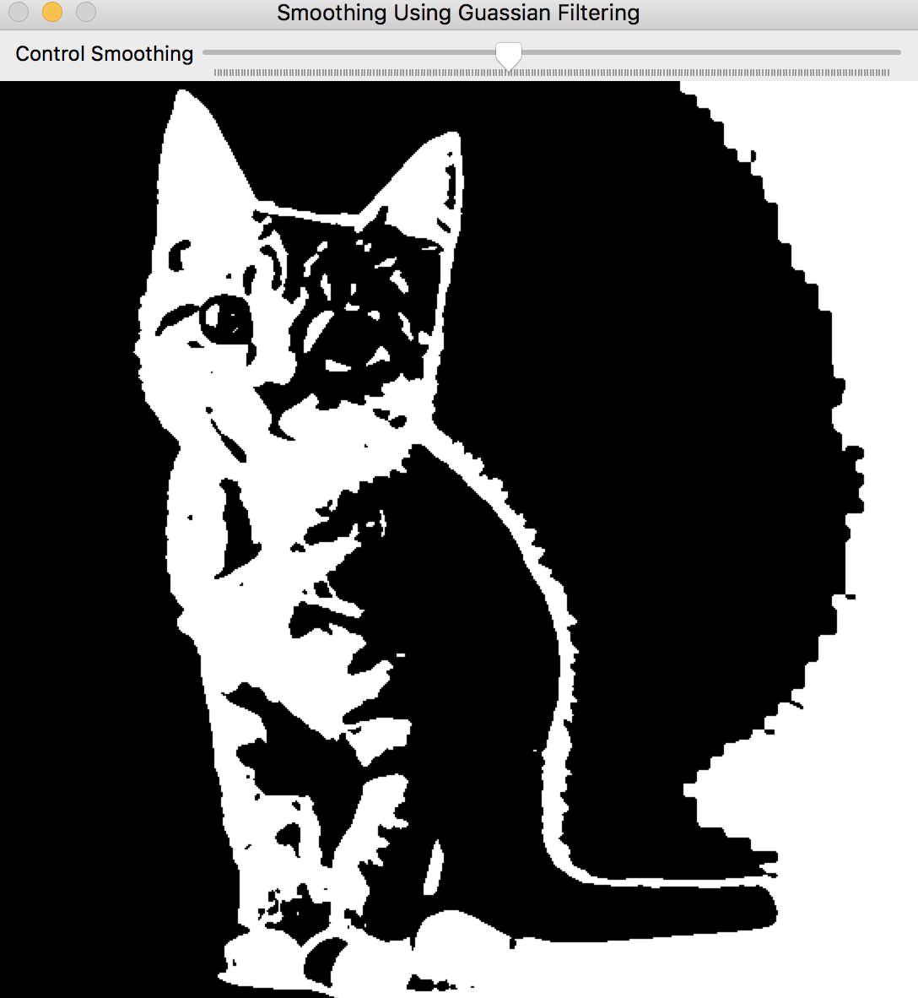

Smoothing with Gaussian Filter (15,15)

**Problem Statement 7:**

Convert the given image into grayscale and then use smoothing using own implementation when ‘S’ key is pressed.

**Proposed Solution:**

In order to perform smoothing, I have given my own defined kernel. As for one-dimensional signals, images also can be filtered with various low-pass filters (LPF), high-pass filters (HPF), etc. A LPF helps in removing noise, or blurring the image.

**Result:**



**Original Image**

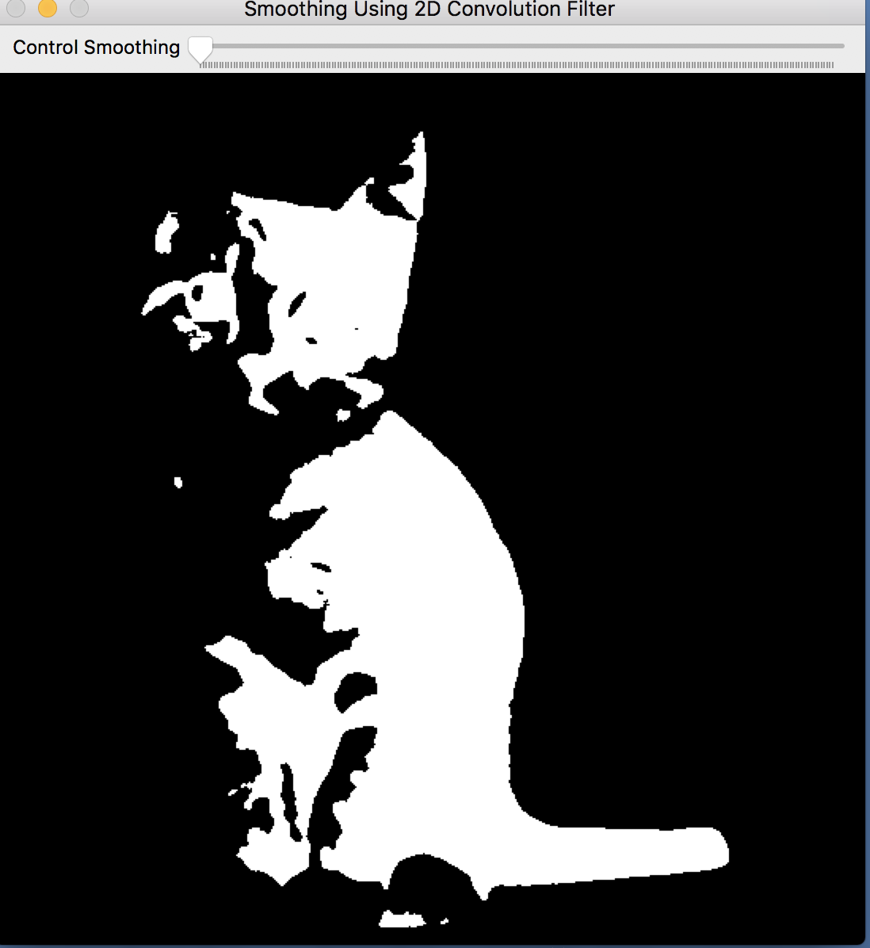

**After applying our own smoothing function**

**Problem Statement 8:**

Down-sample the image by a factor of 2 without smoothing when ‘d’ key is pressed.

**Proposed Solution:**

In order to down sampling, I am simply using cv2.pyrDown() function from openCV.This function is simply creating Gaussian pyramid in order to down sample the given image without changing the intensity.

**Result:**



**Original Image**

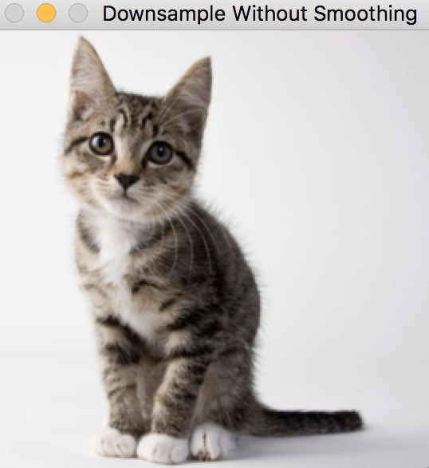

Down sampling with factor of 2

**Problem Statement 8:**

Down-sample the image by a factor of 2 with smoothing when ‘D’ key is pressed.

**Proposed Solution:**

In order to down sampling, I am simply using cv2.pyrDown() function from openCV.This function is simply creating Gaussian pyramid in order to down sample the given image without changing the intensity. This functionality is happening after smoothing is being applied.

**Result:**



**Original Image**

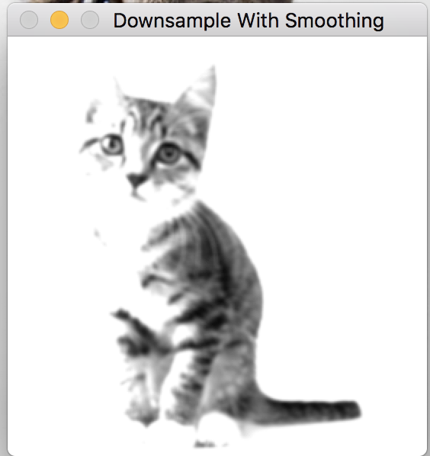

**Down Sampling with smoothing**

**Problem Statement 9:**

Convert the image to grayscale and perform convolution using x and y derivative filter when ‘x’ and ‘y’ keys are pressed. Also calculate magnitude using X-axis and Y-axis gradient when ‘m’ key is pressed.

**Proposed Solution:**

In order to find the image gradient along X-axis and Y-axis, my code is using Sobel operator from openCV. To calculate X-axis and Y-axis gradient it’s using below functions,

/// Gradient X

Sobel( src_gray, grad_x, ddepth, 1, 0, 3, scale, delta, BORDER_DEFAULT );

/// Gradient Y

Sobel( src_gray, grad_y, ddepth, 0, 1, 3, scale, delta, BORDER_DEFAULT );

Finally, to calculate the magnitude of gradient my code is simply using sqrt of X-gradient and Y-gradient after normalizing those calculated values in between [0,255].

**Result:**



**Original Image**

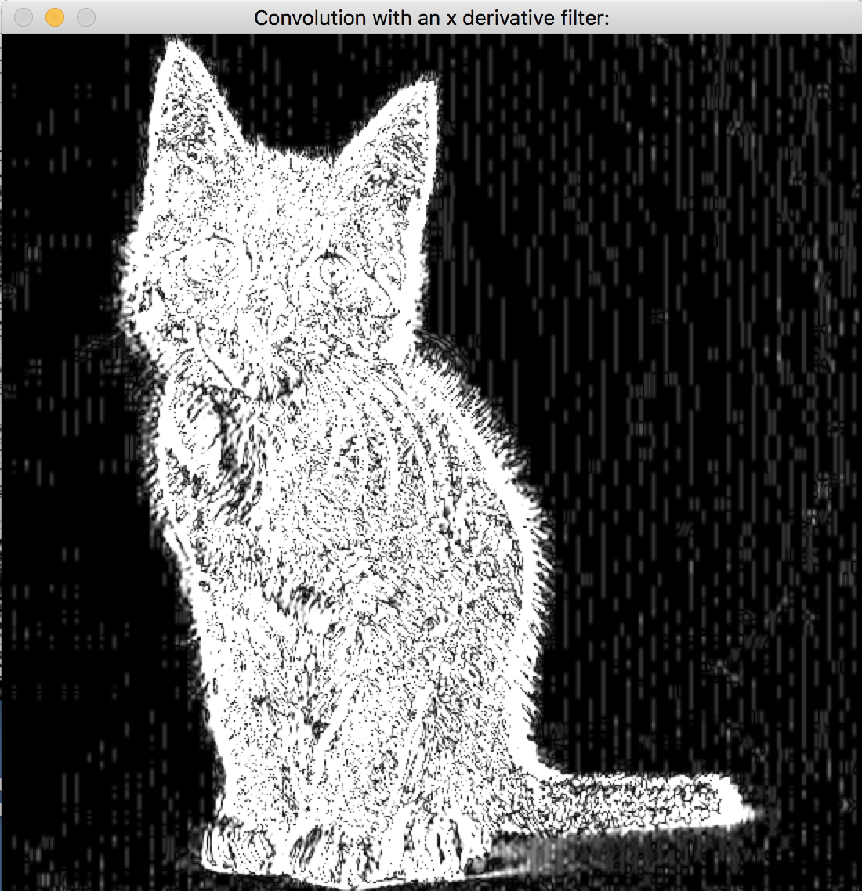

**Convolution using x derivative**

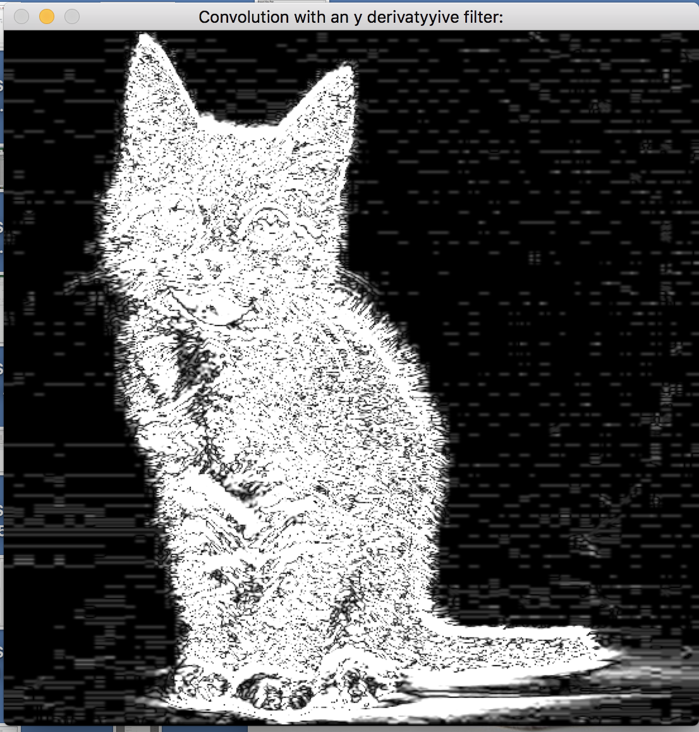

**Convolution using y derivative**

**Gradient Magnitude:**

[[0 0 0 ..., 0 0 0]

[0 0 0 ..., 0 0 0]

[0 0 0 ..., 0 0 0]

...,

[8 8 8 ..., 8 0 0]

[0 0 0 ..., 8 0 0]

[0 0 0 ..., 8 0 0]]

[[0 0 0 ..., 0 0 0]

[0 0 0 ..., 0 0 0]

[0 0 0 ..., 0 0 0]

...,

[8 8 8 ..., 8 0 0]

[0 0 0 ..., 8 0 0]

[0 0 0 ..., 8 0 0]]

**Problem Statement 10:**

Convert image to grayscale and then plot the gradient vector of the image for every N Pixelswhen ‘p’ key is pressed. And also use trackbar to control number of pixels.

**Proposed Solution:**

In order to plot gradient vector, I am first calculating gradient along X-axis and Y-axis using Sobel operator from openCV. Along with gradient magnitude, my code is also calculating direction of the gradient in order to find gradient vector field. After that I am simply converting it to polar coordinate using those calculated values. Here I have also implemented track which will capture the change in number of pixel and change the value of gradient vector field. Below is the code for the same.

gx = cv2.Sobel(gray, cv2.CV_32F, 1, 0, ksize=1)  
gy = cv2.Sobel(gray, cv2.CV_32F, 0, 1, ksize=1)  
img = np.zeros((300, 512, 3), np.uint8)  
mag, angle = cv2.cartToPolar(gx, gy, angleInDegrees=True)

**Result:**



**Original Image**

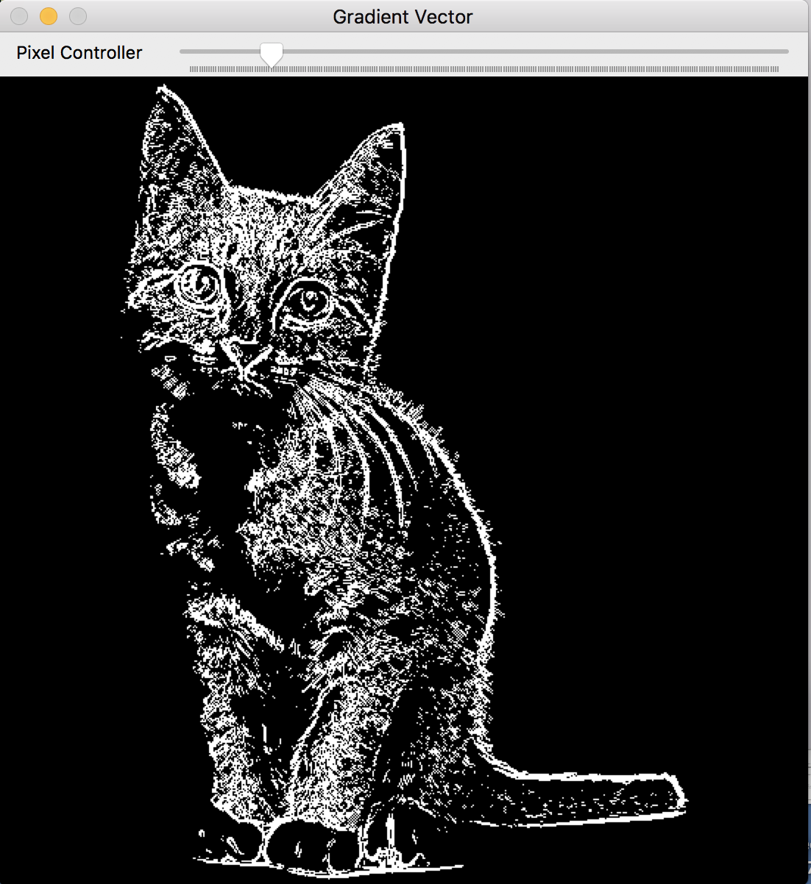

**Gradient Vector plot based on the Number of given Pixels.**

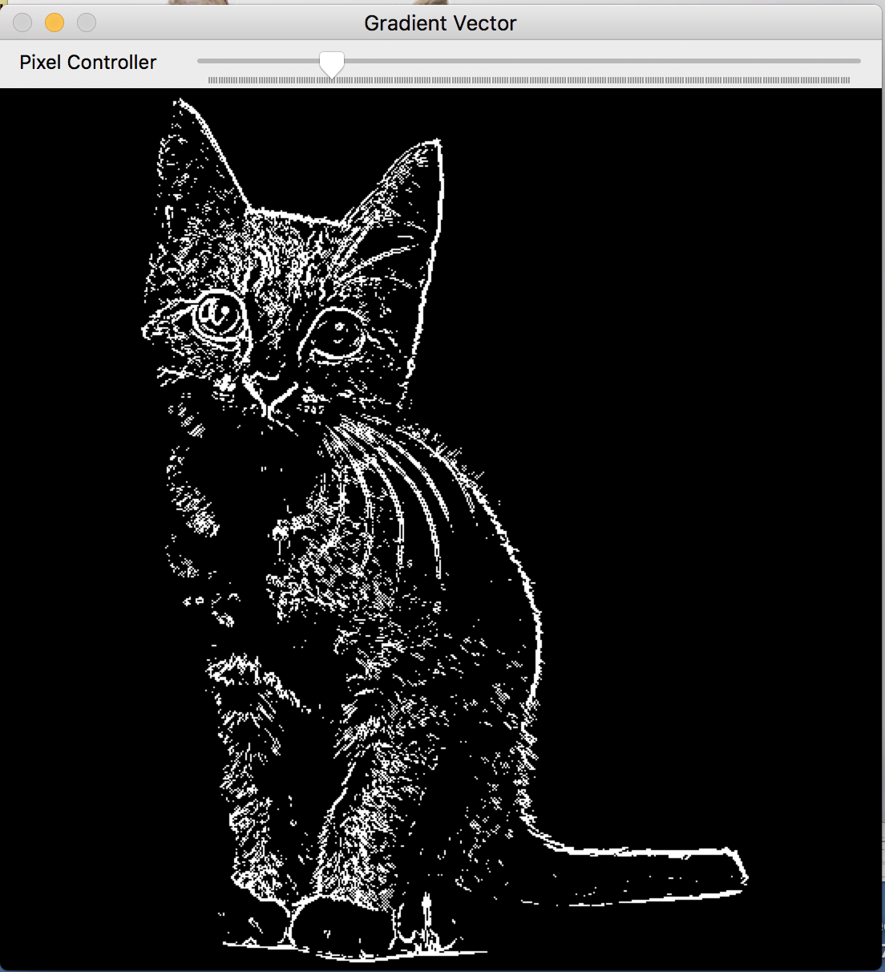

**Gradient vector after changing the number of pixel using Trackbar**

**Problem Statement 11:**

Convert the image into grayscale and rotate it theta amount when ‘r’ is pressed. Also implement trackbar to control the theta.

**Proposed Solution:**

In order to rotate the image, my code is simply finding the 2D Rotation matrix using cv2.getRotationMatrix2D((cols / 2, rows / 2), 90, 1) function. After getting the matrix, I am simply using cv2.warpAffine(gray, M, (cols, rows))to get the rotated image.Here I have also implemented trackbar to control the angle theta.

**Result:**



**Original Image**

